**HAWK M Series *Reference Manual*** V22.11

**Hawk M**

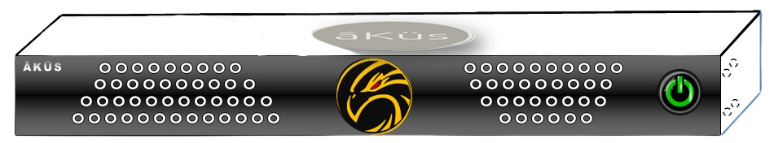

Admin Guide  
(Hardware, Web-management, and Operations)

**Content**

**Hint: -** Ctrl + Click to jump on the page.

1. Hardware
   * Model / Series
   * Mounting and Commissioning
   * Power On device
   * Physical Network Connectivity
   * Check visible status notification
   * Know Your HAWK Device
   * Support
     + RMA - Hardware
     + Tech Support Ticket – Software
     + 24X7 Contact Line
     + Video Tutorials and Black book
2. Software
   * Version
   * Pre-requisition and Compatibility details
   * User
     + Super Admin
     + Admin
     + Users
   * Factory Reset
   * Configuration
3. Operations
   * + Default Roles
     + Modules Tour and management:
4. Administration
   * + login

* Web-Browser (GUI) Access
  + - * Registration
      * Forgot Password
      * Terminal and Serial Console
* Hawk self-care
  + - Hawk Live-Monitoring
* Home Dashboard
* Top Toolbar
  + - info
    - Review
    - Notification
    - Tickets (Incidents-SLA)
    - Trigger
    - My Dash
    - Live-Watch
    - Quick Manage
* (Assets Management) DCIM
  + - Hawk View
    - Management
    - Cables
    - License Management (LMS)
    - Miscellaneous

1. Modules

* Network (NMS)
* Server (Physical & VM)
* Storage Monitoring (SCM)
* Database Monitoring (DBM)
* Application Performance Management (APM)
* Web Monitoring
  + - CDN
* Security Monitoring (IP)
* Reports

1. Contact us
   * + Tech Support Ticket – Software
     + 24X7 Contact Line
     + Video Tutorials and Black book

Sample/Tips/Note points/Important Sample

**֍ Tip:** Sample Tip for users.*Important tips will be served you time to time in the black book*

**Hardware**

* + Model / Series

There are different variants which suits all kind of IT infrastructure environment. Whether Centralized, De-centralized, Large Scale facilities, Standalone or Distributed, Private Cloud, CoLo(cation), Sharing, or on-premise. Caters to all IT Infrastructure.

* Hawk M - P1L2x32 //Know more www.akus.io
* Hawk M - P1L2x64
* Hawk M - P2L2x64

________________

* Hawk - X, Xe //Series for Private Cloud

________________

Hawk C - Flexible Cloud NMS //Know more www.akus.io

* + Mounting and Commissioning

Please check Manual copy dispatched inside the packaged box. If you have lost it, please request from [support@akus.io](mailto:support@akus.io).

* + Power On device

Device default mode is in power fault-tolerant mode. Which helps to keep device utmost up and running. Power button also has certain functioning with different pattern to press power button.

* A connected Power chord will start the device immediately
* Press once to restart device gently (Restart the device in safe way)
* Press and keep hold for three seconds to enforce power off the device (Device will reset to fault-tolerant mode once power chord unplugged)
  + Physical Network Connectivity

Device has multi network high bandwidth ports. User can customized connectivity according to their IT environment and requirements.

* WAN / WAN
* LAN / LAN
* WAN / LAN
  + Check visible status notification

Device has indicator LEDs in-front face side of the device. Left - right LED active status show device’s storage and power activeness.

* + Know Your HAWK Device

Please check your model details at our official website: [www.akus.io](http://www.akus.io)

* + Support

Below services are available at official website: [www.akus.io](http://www.akus.io)

Check support section for below requirements

* + - RMA – Hardware

To replace the faulty component / device.

* + - Raise Ticket (Tech Support)– Software / Hardware

User can book a technical support ticket at our website. Fill up the details and send directly to us.

Also, within device IMS section from header. User can raise ticket through device directly.

* + - 24X7 Contact Line

**India Support**

helpline number **Toll Free - 1800 309 9987**

write us: **support@akus.co.in**

**Global Support**

write us: **support@akus.io**

* + - **Video** Tutorials and **Black Book**

Tutorial and knowledge base videos are accessible at our YouTube channel.

<https://www.youtube.com/channel/UCyVzMWHTRAXCvjtw48XaNaQ>

Black Book: This document is Black Book.

**Software**

All models Embedded with Hawk Multi-Core Engine. Performance and Smartness together. All models are Plug N Play model. However, more depth level of enhance monitoring and management. User can implement one or more methods like SSH, Telnet, SNMP, API, etc.

**Operations**

There are different roles are ready to be configured in easy and opportune with prebuilt templates and default super admin user.

Default Roles:

Pre-loaded roles are denoted by given below

1. Super Admin User (hawk)*: Prebuilt non-removable user. This user is the highest in the authority. This user acts as a competent authority to approve and reject the request from second authority admin users for critical decisions. Hawk is unique and top in user hierarchy with complete privileges.

User has unique functionality to transfer own rights to any specific admin user by a simple enable and disable function in administration inside admin settings. Enable allows choosing one admin to self-authorize the requests. This hybrid admin serve as an approval and administration privileged user both.

1. Admin User: Prebuilt removable user. This user is the second highest in authority. This user acts as an administrative authority to approve and reject the request from the executive/ end user level. There could be multiple admin users. An admin cannot create an admin user (equivalent privileged).
2. Staff: Can be managed through admin users. These users could be part of Groups, Departments, Clients, Projects and, teams with assigned privileges and roles.

Generally users have view, Monitor and, analysis privileges.

For Eg: DC Operators: Administrative team to manage, monitor and operator with predefined access.

**Administration**

* **Login**

1. **Web – Browser (GUI) Access:**   
   If you have configured the device. Go the path:   
   Sample:[**https://10.10.10.1**](https://10.10.10.1)**0 (***Here 10.10.10.10 is assigned IP address of your device*)   
   A login page will display as given below

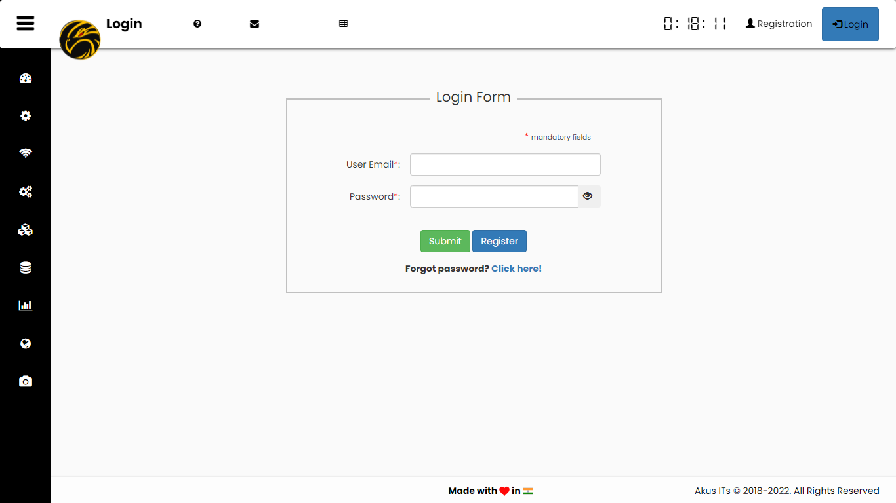

**֍ Tip: Factory reset credentials for appliance.   
 Default username and password for Super Admin (case sensitive)  
 User id: hawk   
 Password: hawk123**

1. **Registration:** Anew user can request for new account to admin through Registration form. User will be able to login once request approved by admin. A sample is given next.

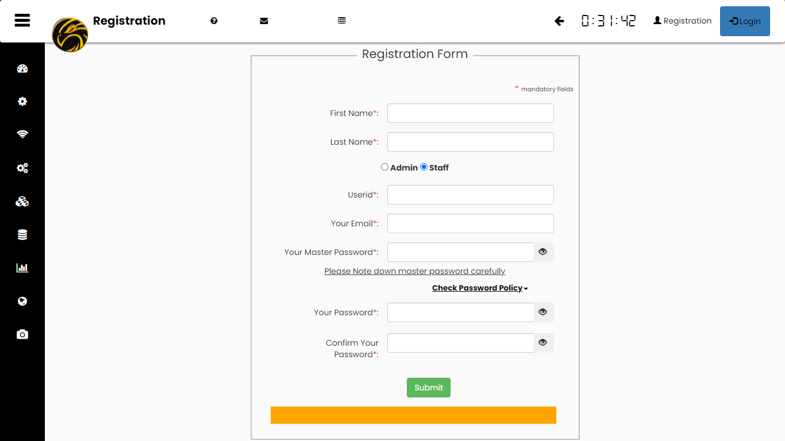

**֍ Tip:   
Keep your master password safely with you for future references.  
Note: Admin cannot reset the master password. If you forget master password,  
either admin have to recreate the user again or discard for forever**.

1. **Forgot Password**

User can easily reset the password through their master password validation. New password will be approved by administrator user.

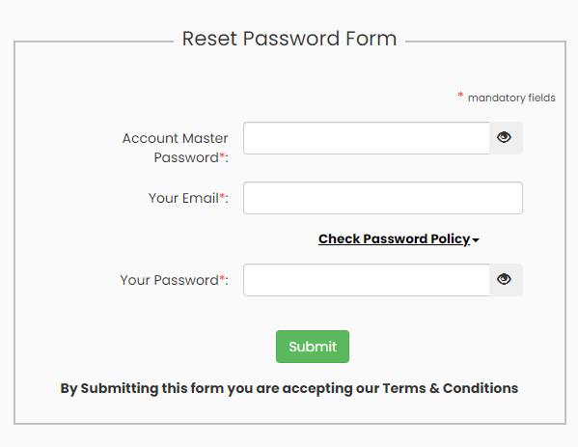

1. **Terminal and Serial Console**
2. **SSH:**  Hawk is enabled with SSH console support.
3. **RS232**: Check your model and datasheet for access details.
4. VGA: Check your model and datasheet for access details.
5. HDMI-D*: Check your model and datasheet for access details.
6. HDMI: Check your model and datasheet for access details.

* **Hawk Self Care**
  + **Hawk device’s health Info**

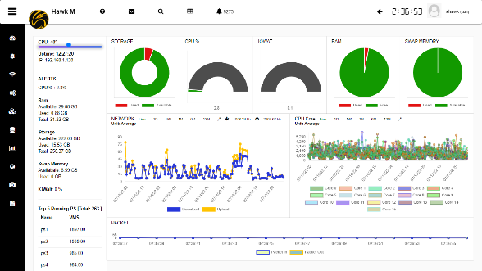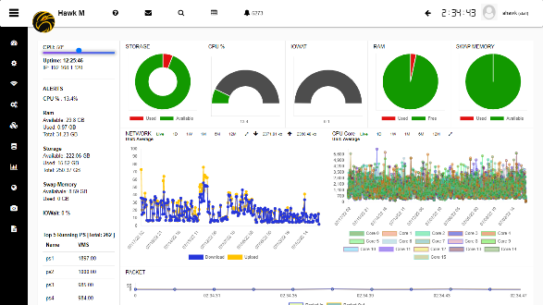Hawk device are smart IoT enabled device. It monitors its own health and report for any misbehave and heads-up condition of device. Device dashboard can be access through directly click on Hawk Logo Icon inside Header.

**Stats:**   
section comprised with statistics and important information to display in tall tabular formats. Alerts –Real-time latest critical alerts related to the device can be seen here.  
Critical resources – live interactive visualization for critical resources.

Network Utilization – Monitor network interfaces for device

CPU Utilization – Hawk is powerful multi-core-threaded processing based system. Which handle the entire resources request in optimized distributed manner. Hawk engine, compact yet powerful Hybrid multi-core engine for the multi tasking. (Pls refer model details)

Process Stats (Top running processes) – Identifies abnormal behavior of services and applications inside the device.

Packets Status – A continuous and un-interrupted data-supply for Hawk long lasting performance.

IO R/W Utilization – Disk Read/Write status, ensure smooth functioning during operations.

Rest all devices have their dedicated home dashboard (1st Home Dashboard) Left side in the toolbar.

In the successive section we will explore each one for you.

* **Home Dashboard**

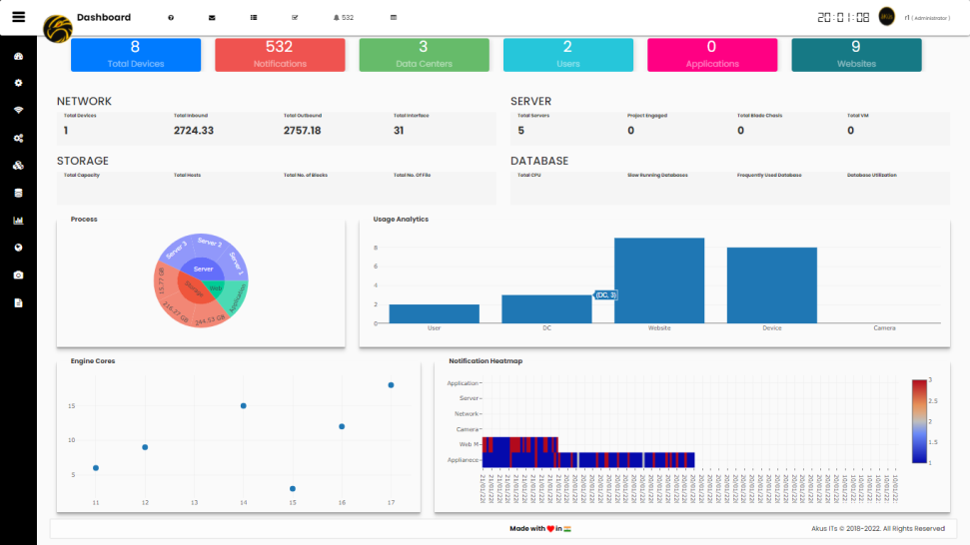

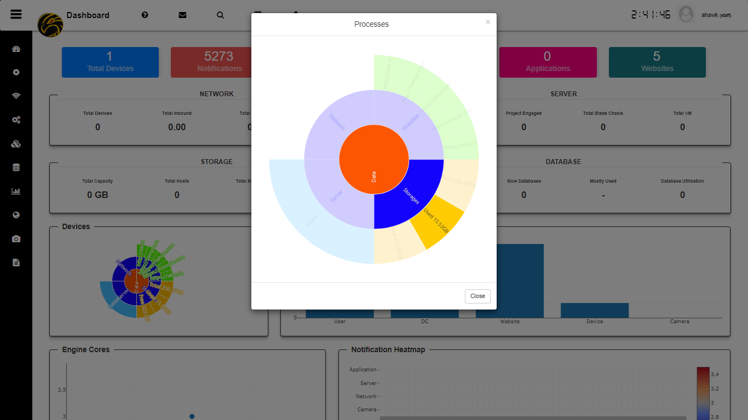 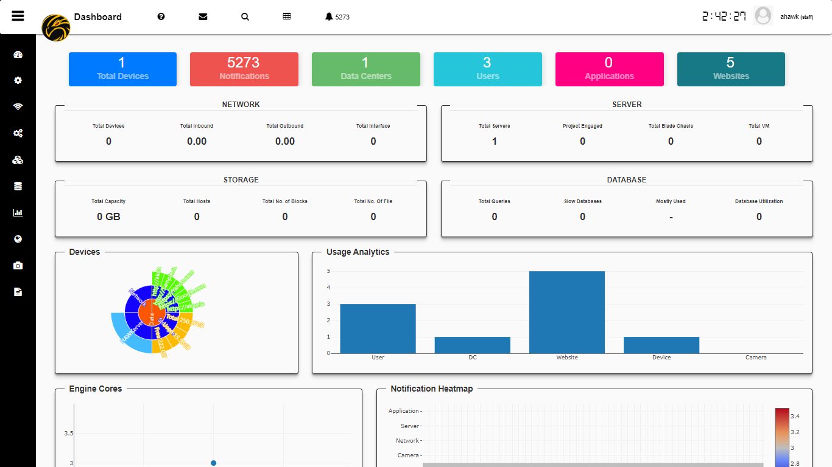

**Stats**Hawk Dashboard gives you a holistic summary view of all devices, Notifications, and their stats. In the top of Dashboard counter section helps you figure out critical information in quick and easiest way. Including but not limited to Total devices, Notification counts, Total Datacenters / server rooms, users, Applications, and Web URLs.   
Interactive Pie chart helps you to select and gather quick useful information about multiple categories of device. An interactive bar chart gives real-time inventory details.   
An engine cores chart identifies how many different native protocols (Core) are running in backend and their real-time packet traffic.

A heat-map chart gives a quick weekly view of your notification(s) with respective to its service(s).

* **Top Toolbar**

* + **Info**
    - About us – Know more about us. Please visit the section.

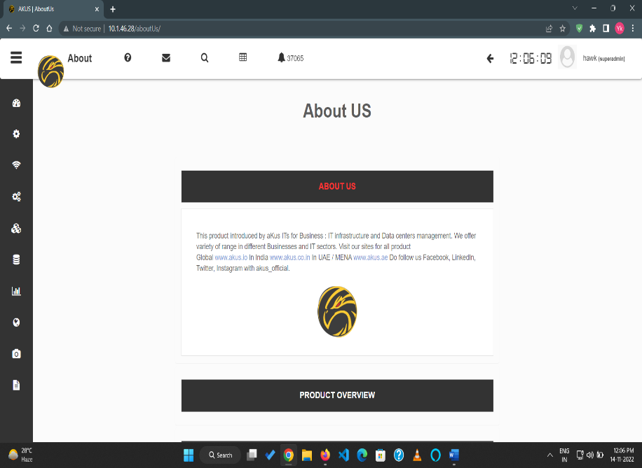

* + - Product Overview – Get to know about your product.
    - Product Series & Version – Find out your device family and version details.
  + **Review**
    - Search devices – search your devices for real time interaction with them, refresh connection, pre-requisite testing and Quick status for the device(s).

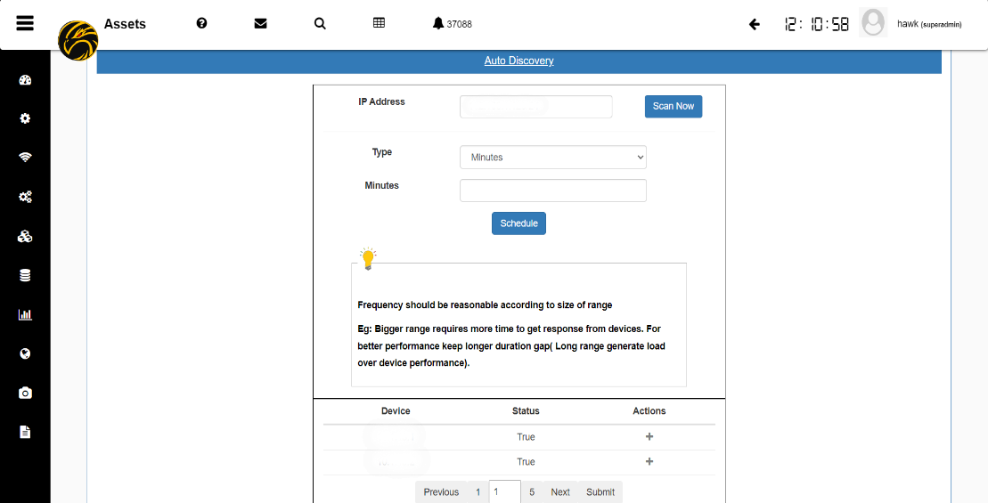

Add With Blue Plus Button

* + - Fetch Data – Identify your important statistics anytime and manage to add as a new service chart to personalize your experience.
  + **Notification** 
    - Top 5 High alerts – identifies latest and top 5 high and critical alert notifications. So, you can easily prioritize your infrastructure immediate attention seeker requirements in a click and acknowledge.
    - See All notification
      * *Key Performance Indicator (KPI) –* Plan your resources with advance KPI section. Be informed, stay planned.
      * *Bulk actions –* Allows user to perform bulk options (For eg: Acknowledgement, Archive, etc)
      * *Manage Alerts –* Individual each notification can easily be managed. User can manually assign alert as an Incident ticket to respective device owner or let Hawk handles your all alerts automatically to owner in 30 min no response.
      * *Notification Archives –* All the expired alerts could help us to do in better planning or to handle un-identified issues. So, we keep them in our Archives.
  + **Tickets:**
    - Report us – We listens your all technical related query or feedback. Leave your technical query to us. Get best guidance from our experts.
    - Raise ticket – Manage alerts / Incident tickets, assign them to your warrior teams with SLA and track their status in order to achieve your SLA goals.

**֍ Tip:   
Hawk SLA: Set a goal to hawk and relax. Hawk manages your all SLA with KPI support. So, you’ll** **never miss your SLA target ever now.   
Note:** **A Smart way to manage your all SLA – Use Hawk Auto SLA feature.   
Administration – Auto SLA – Enable / Disable (Default Critical Threshold time – 30 Min)**

* + **Trigger:**

You can manage your triggers by easily select desired threshold point for the device.

Default it’s enabled for best performance mode. Keep it enable, that’s it. You are good to go .

* + **My Dash**
  + Monitor your most critical devices in your personal dashboard. So, hawk will show-up only what you are keen of.
    - **My Dashboard**

All your favorite marked device will appear in your personalize dashboard. Easiest way to keep an eye on your important and critical devices.

* + **Watch –** A live time-watch will always ensure effectiveness, attentiveness of time and utilize it in the best way as timestamp for all screenshots.
* **Quick Manage**
  + **Admin Setting -** Dedicated portal for all management of an Administrator / Manager.

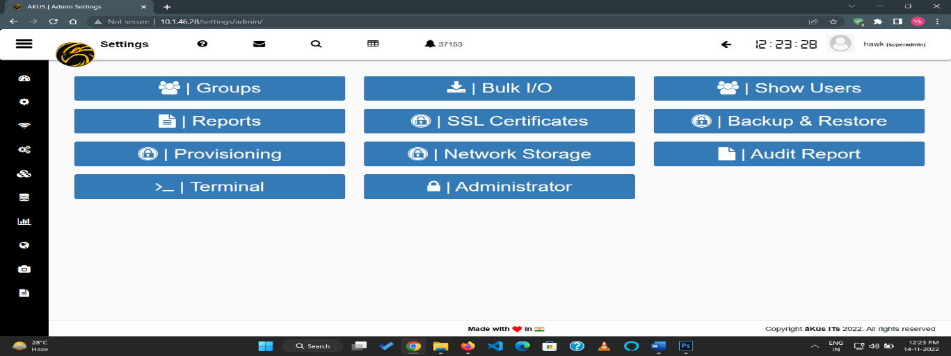

* + **Settings -** User profile alteration and updating.

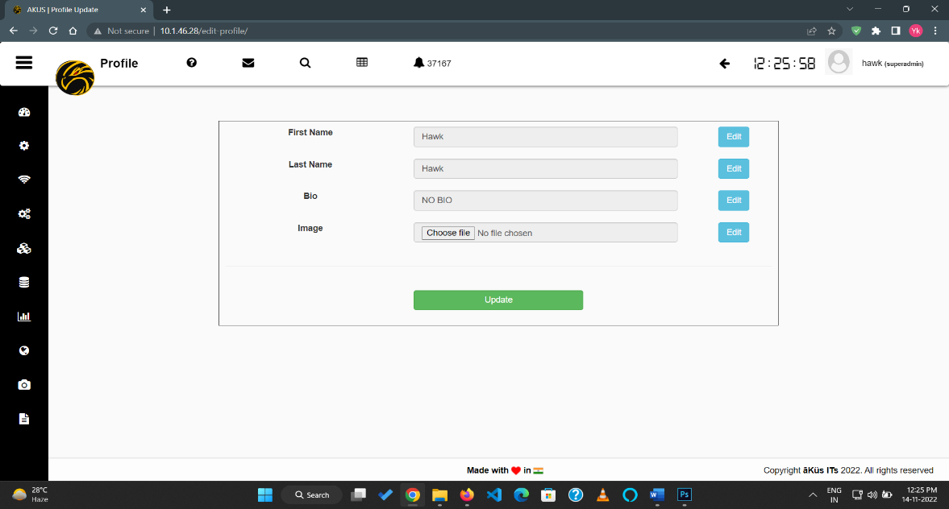

* + **Logout –** logout the session of user (Default: Operator / Data Center groups have secured long session connectivity).
* **Asset Management: (DCIM)**

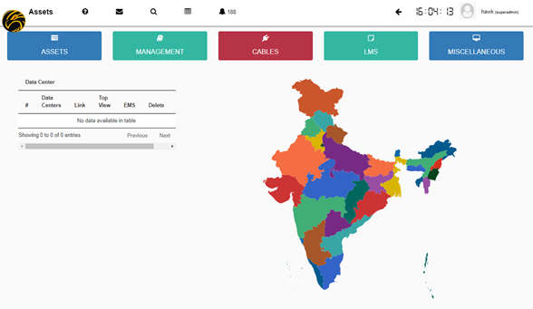

* + **Hawk Assets View** 
    - Holistic Hawk view for entire nationwide. Unlimited distributed / On-premises Infrastructure summary and quick links for redirection. Location based identification for your all assets. Hawk let you manage Assets in quick and easiest way.
  + **Management**
    - * Auto Discovery (Hawk Scan) – Select your network range segment and schedule to Hawk scan automatically in a periodical gaps.
      * Ad Hoc Search – Search and add an individual device.
      * Retrieve Devices – Check Hawk Inventory of the device details.
      * Commissioning – 4 Forms commissioning for your entire Infrastructure. Also supports bulk actions and custom template creation for reusability.

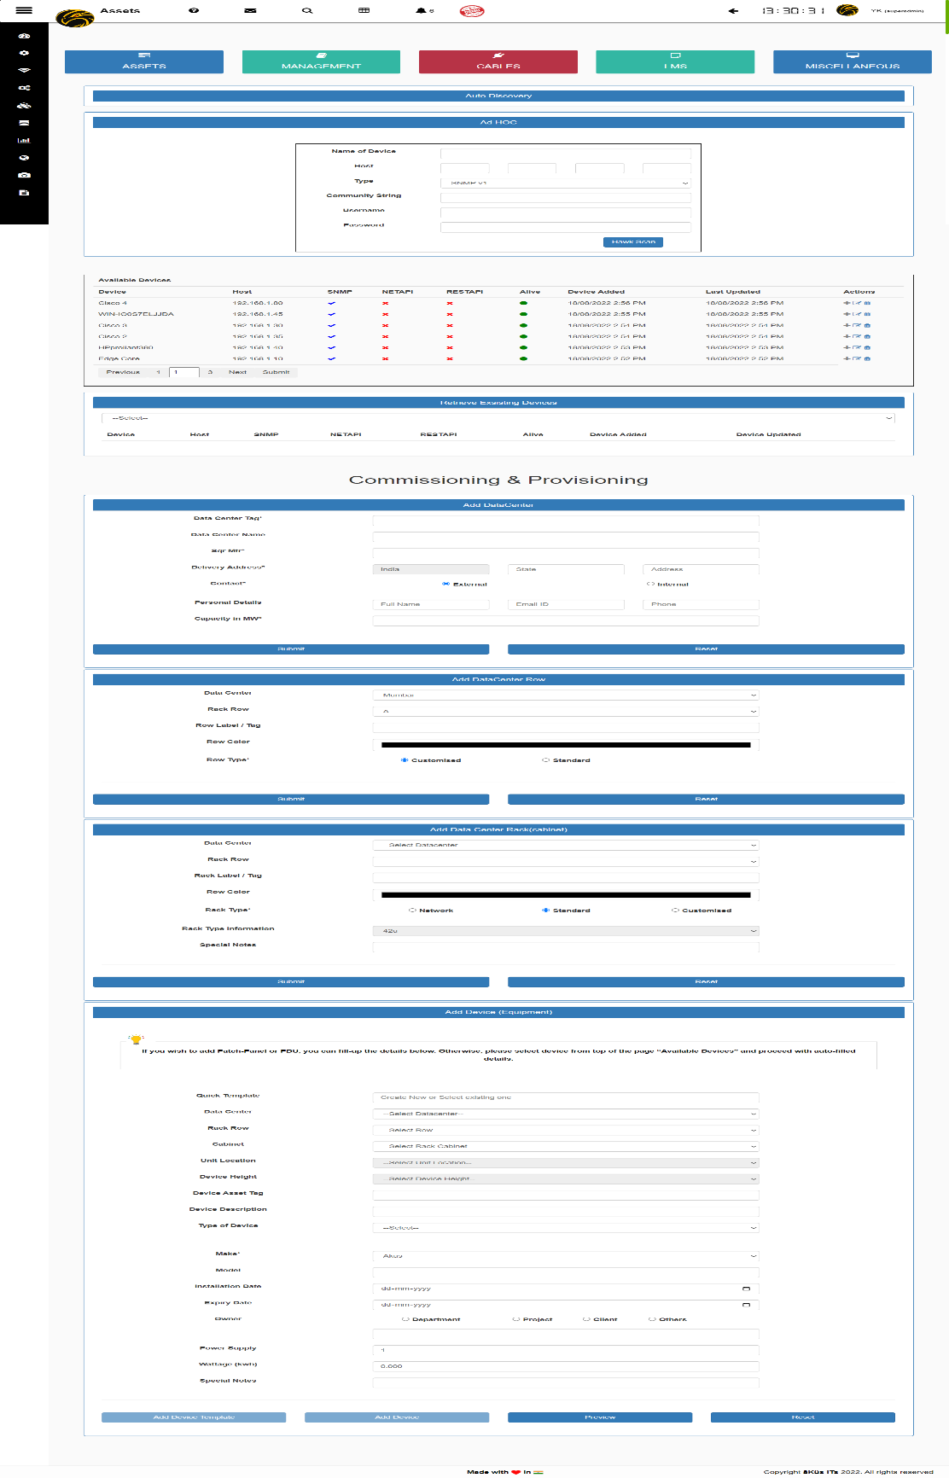

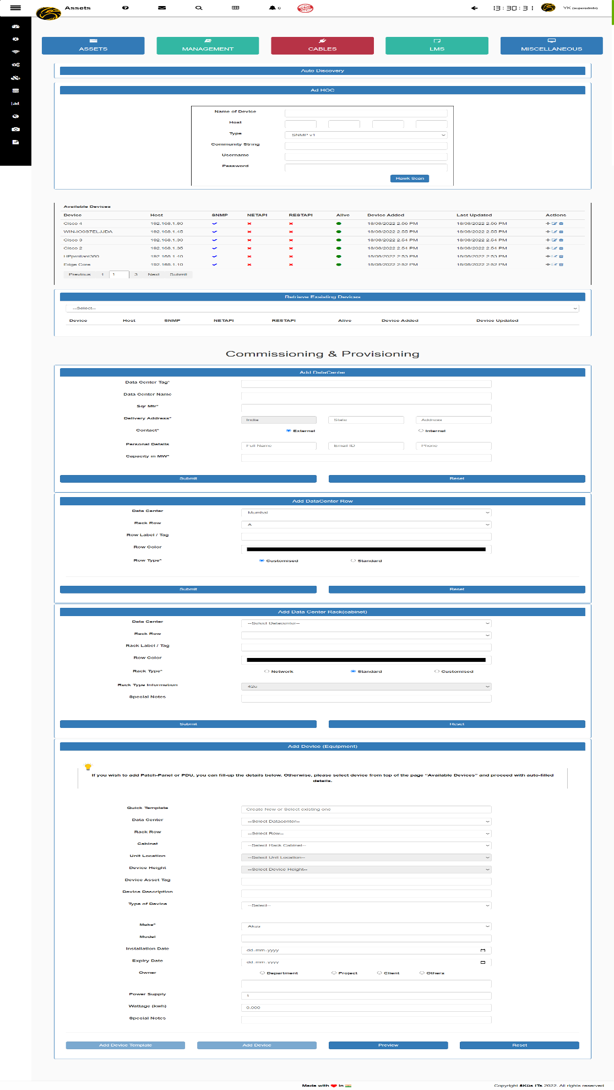

* + **Cables** 
    - * Stock – Cable management and Stock summary

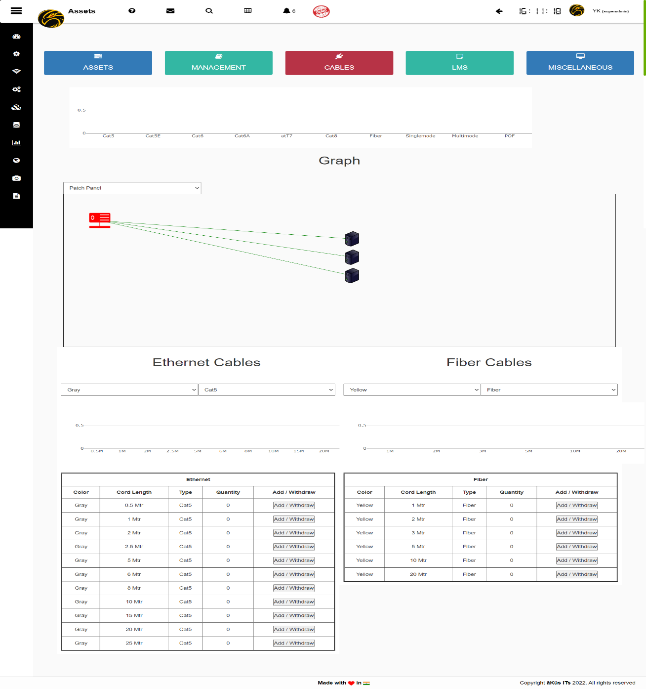

* + - * Connectivity Chart – Know real-time connectivity for your Patch panel and rack mount device. Let you identify and trace cabling quick and smooth. No need to physical visit and LAN tester tracing now.
      * Manage
        + Ethernet Cables – All general types of cables and length support
        + Fiber Cables - All general types of cables and length support
  + **License Management (LMS)**
    - Devices info – Get devices license management at next level. Hawk auto prioritize the most device according to their support end-up for license. Your team will no more need to remember the confusing dates for renewal of licenses.
    - Archived – EOL / Expired devices can be easily fetch and help you to plan accordingly.
  + **Data Center Hall & Rack**
    - Data Center Hall- Show all devices location and about devices name and his rack rack position.

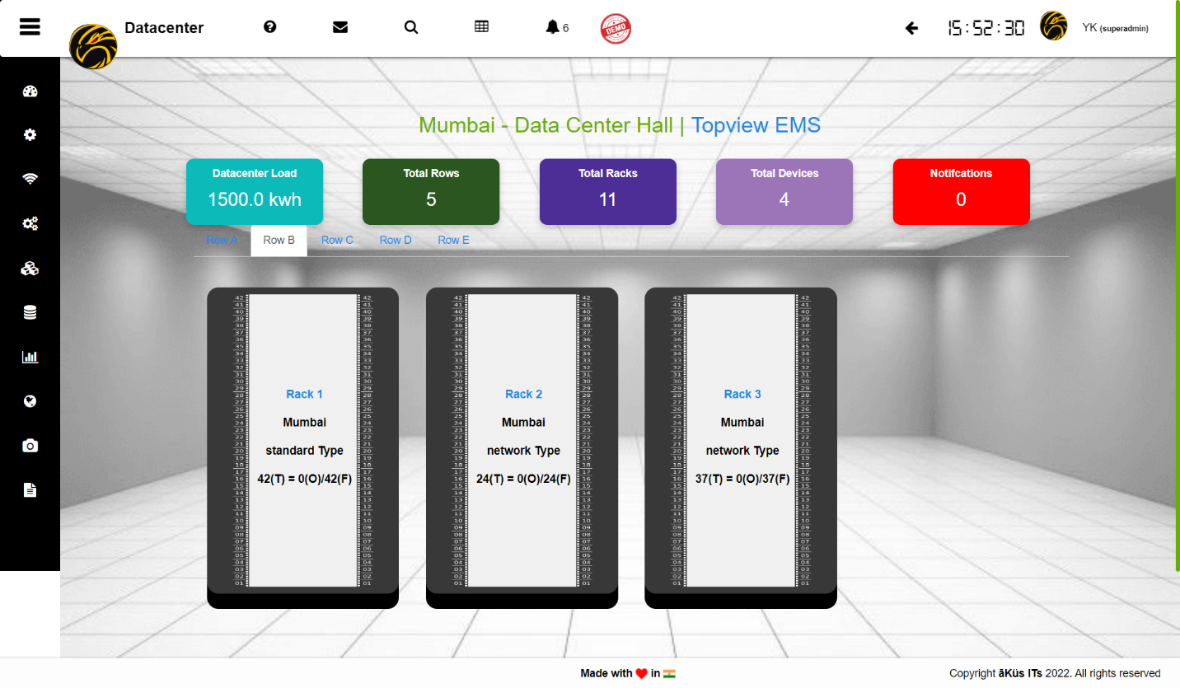

* + - EMS- Display all rack and it’s temperature all device show on 3D view.

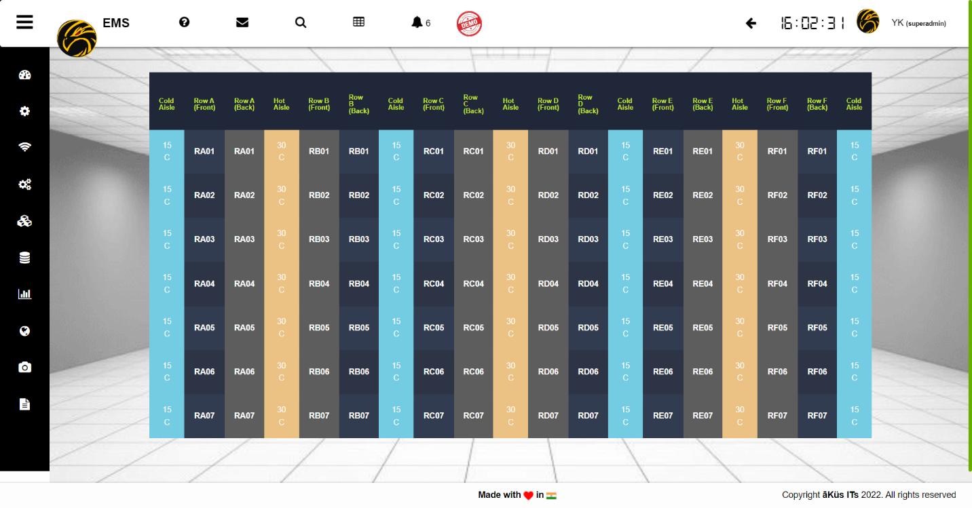

* + **Miscellaneous**
    - Decommissioning – Decommissioning in only 2 clicks help you to manage and record assets for capacity planning and inventory record.
    - Power usage efficiency (PUE) – Download PUE certificate (For A,B, & C). Know live progress for your IT Infrastructure journey YoY and get certified by hawk. Stay advanced with Hawk and brings your efficiency upmost.

**֍ Tip:**

**My Dash: Set a personal dashboard. User can select any device dashboard in his personal favorite dashboard by marking Star to them.**

**Devices will start appearing in your Personal dashboard immediately.  
  
Note:**  **Keep Critical devices in your personal monitoring for better focus**

Modules

Through different modules, hawk perform full sky monitoring and notify the challenges in real-time. Let’s move on to explore each of them with their astonishing features in this section.

* + **Network Monitoring (NMS)**
    - Network Summary – All Network Devices Summary at top helps you to gather all information of module.
    - Topology – Advanced auto generated topology. Connectivity neighbor info, full view of actual traffic, Bandwidth capacity and consumption. Support all layer and level topology architecture.

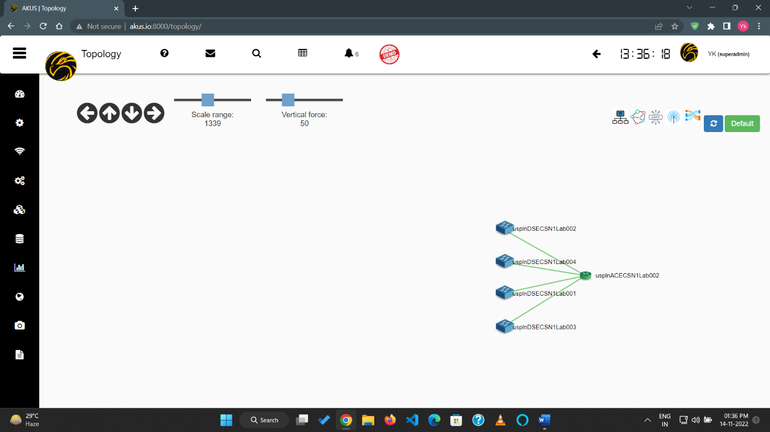

* + - Device(s) Dashboard – Further device dashboard is collection of all monitoring details, Threshold settings, direct console, Log reports, Bulk patching / Orchestration, Mark to personal dashboard, Depth details of ports, and management function.

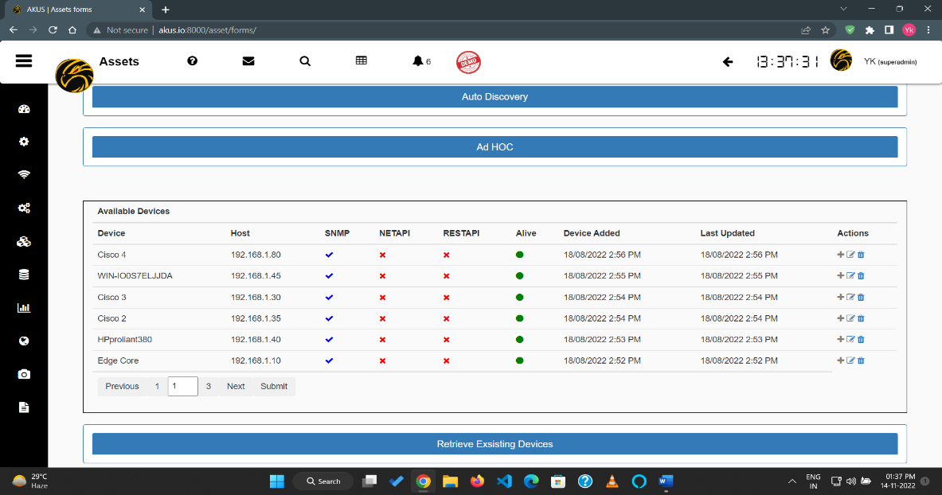

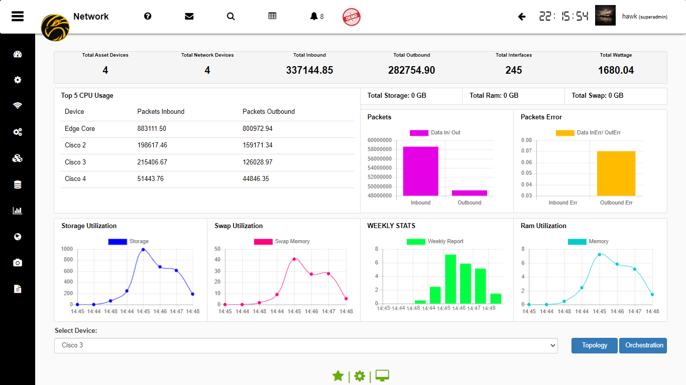

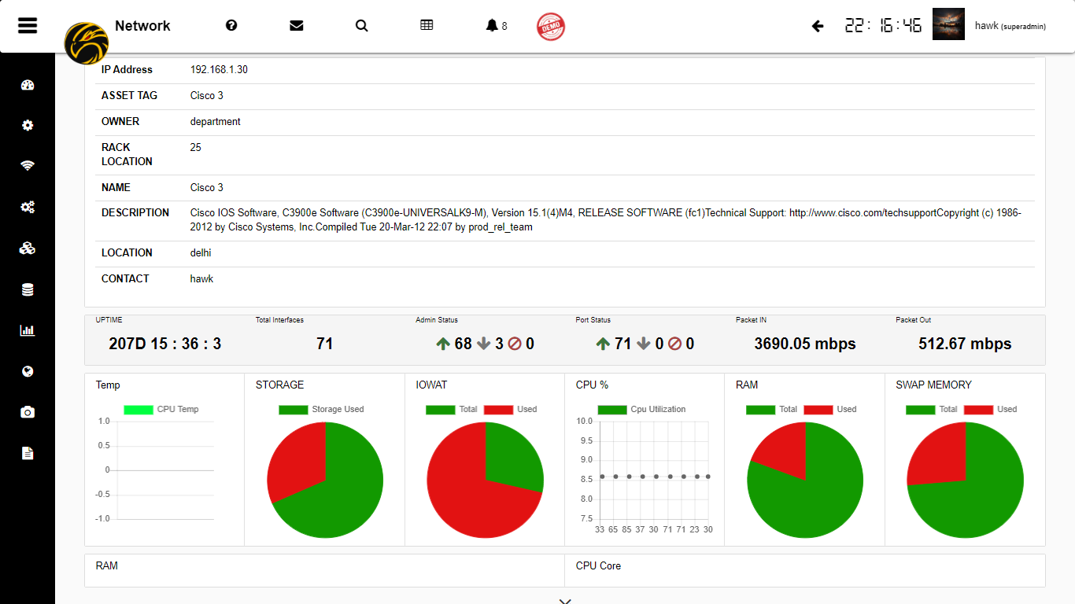

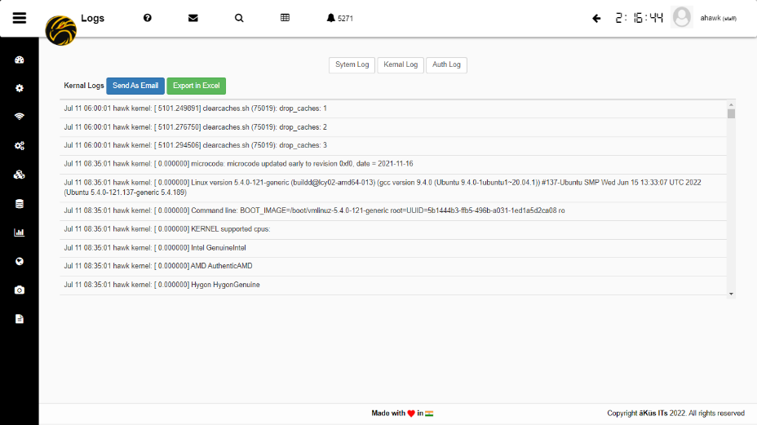

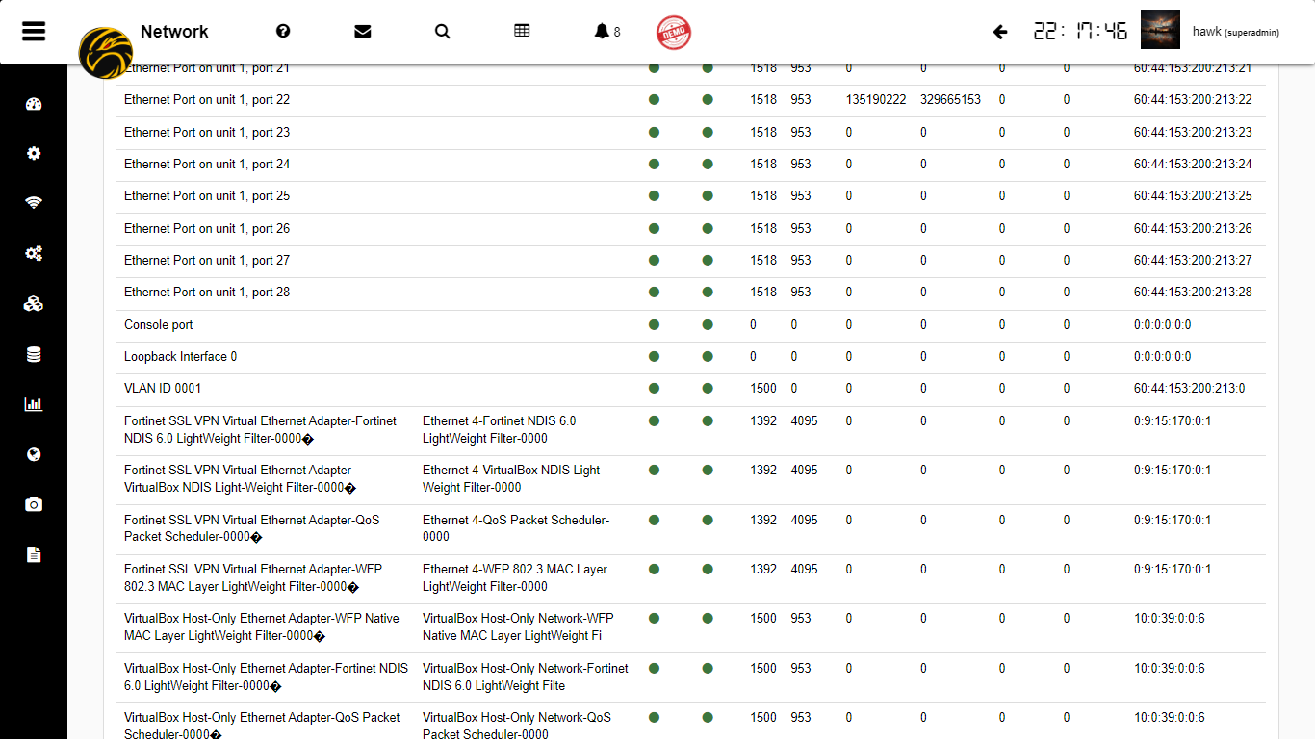

* + **Server Monitoring** 
    - Servers Summary - All servers Device Summary at top helps you to gather all information of module.
    - Server(s) Dashboard - Further device dashboard is collection of all monitoring details, Application performance and management function.

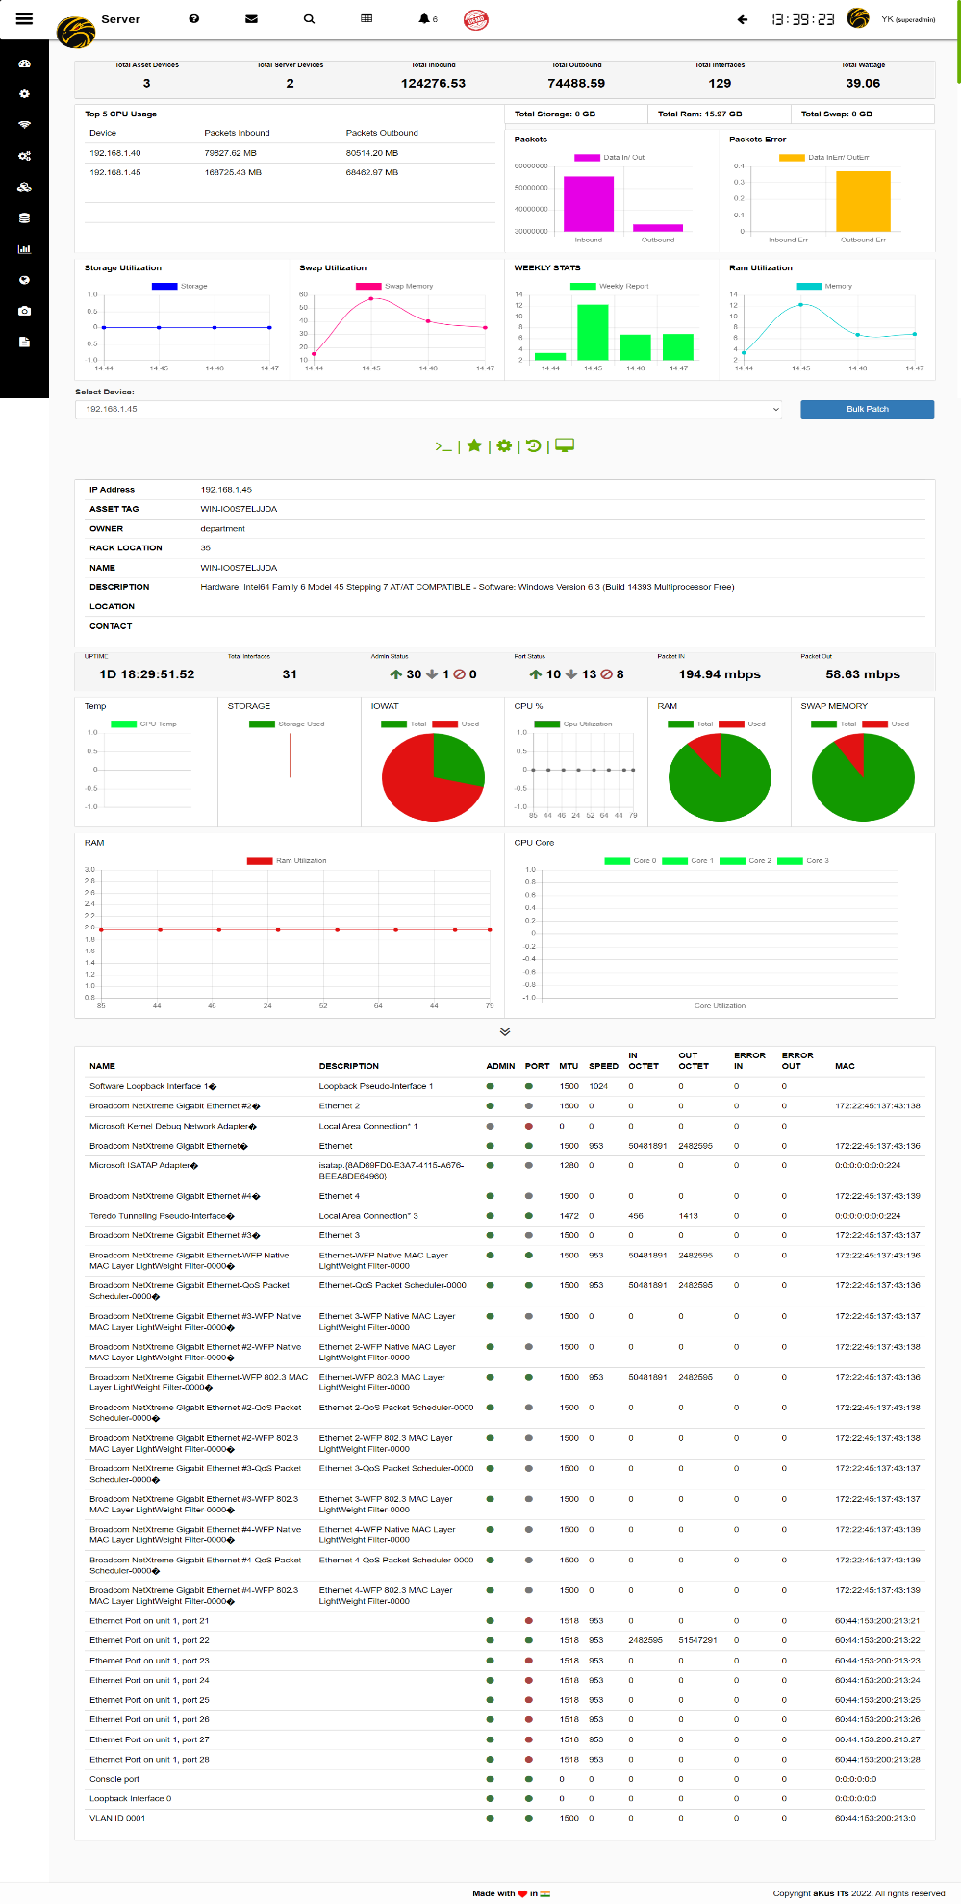

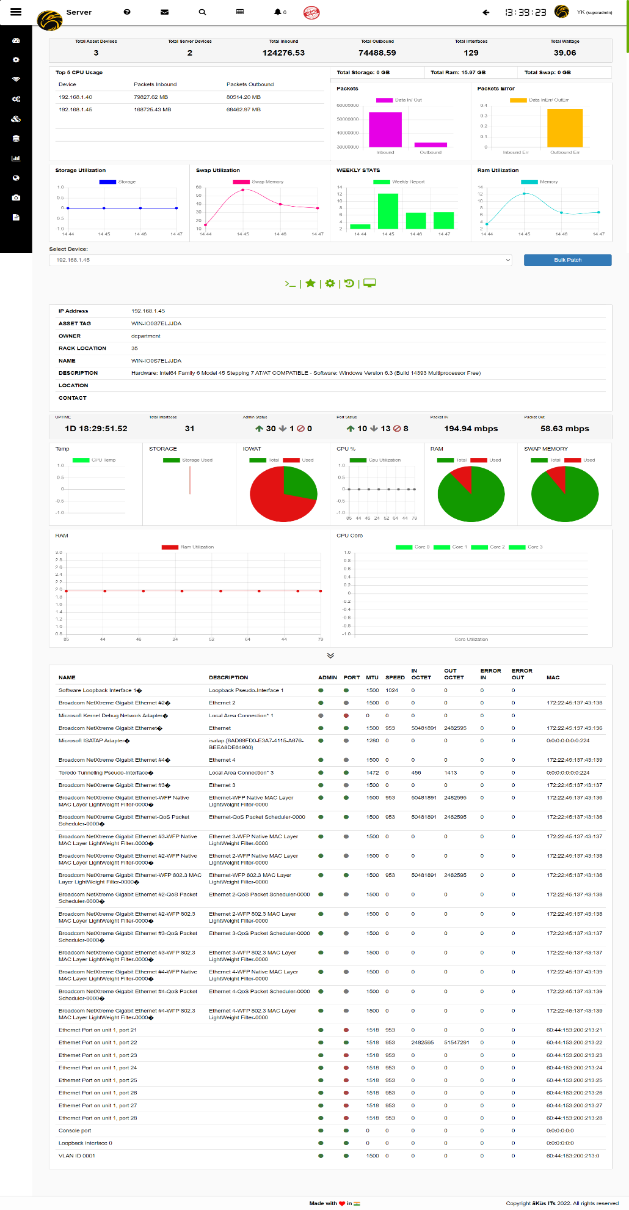

* + **Storage Monitoring (SCM)**
    - Storage Summary - All storage Device Summary at top helps you to gather all information of module.
    - Storage(s) Dashboard - Further device dashboard is collection of all monitoring details and management function.

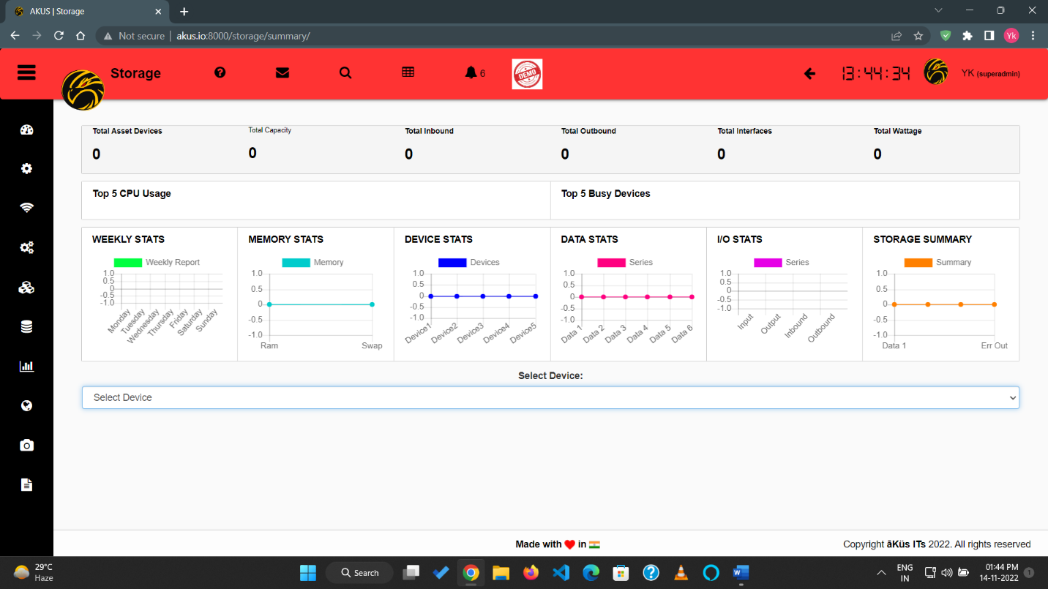

* + **Database Monitoring (DBM)**
    - DB Summary - All Databases Summary at top helps you to gather all information of module.
    - DB(s) Dashboard - Further device dashboard is collection of all monitoring details and management function.

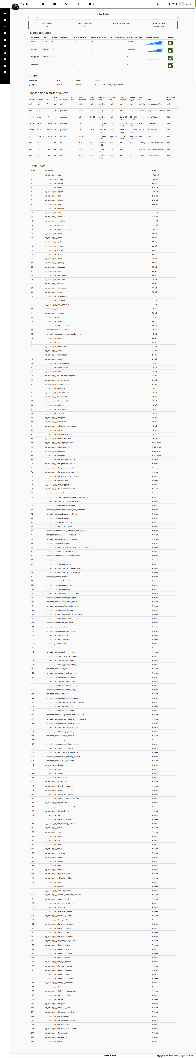

* + **Application Performance Monitoring (APM)**
    - Search Application – select desired server from hawk provided drop down. Enter your desired service/ application and immediately you’ll get status and chart for application / service. Mark favorite to add in permanent dashboard.
    - Application Chart – View server summary for applications and status

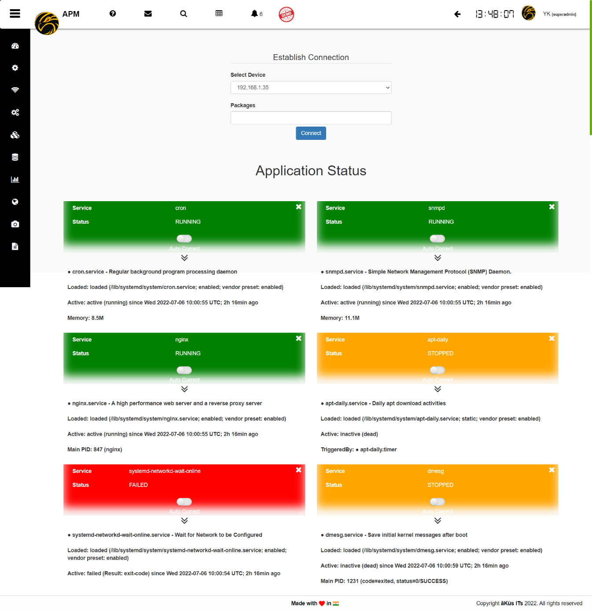

* + **Web Monitoring (WSM)** 
    - Easiest way to monitoring Urls and your critical websites with Global connectivity check and security status. Unique Bucket graph Track timeline performance of Url through time line chart. Bucket Dashboard is monitored with strong analytic concept to help you to focus on problems first.

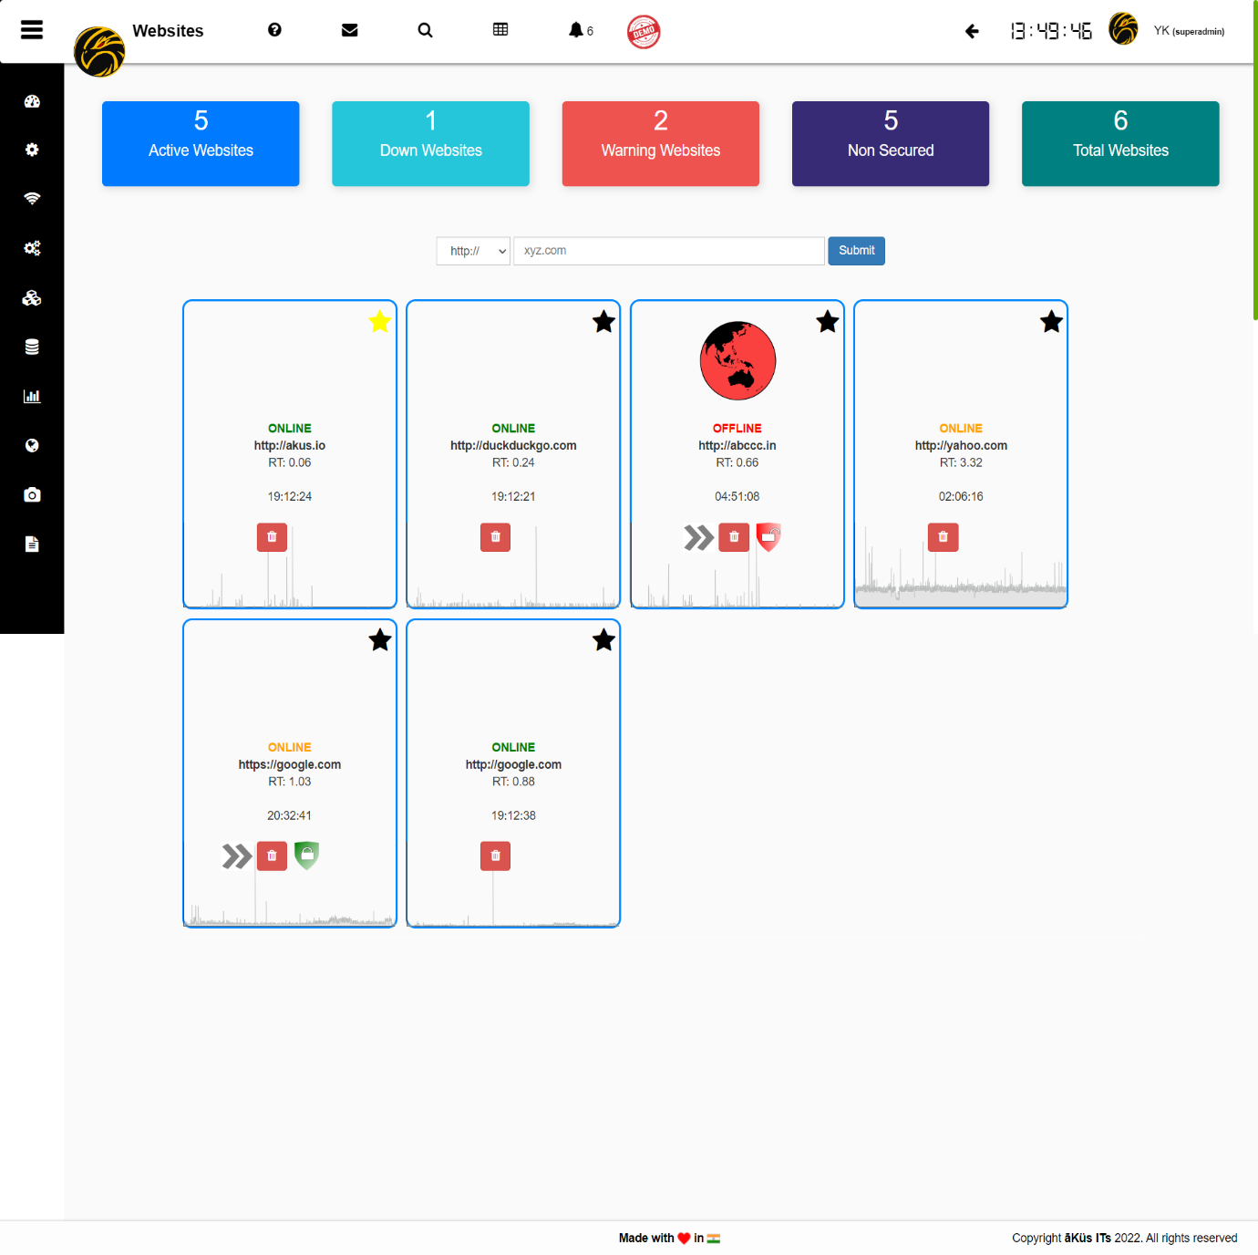

* + **Security Monitoring (IP /CCTV)**
    - Monitor, Stream, and Record your important cameras in Data Centers and premises.
    - Record in silent way without streaming
    - Click and play for live coverage and disaster monitoring.
    - You can download your recording in one click only or let the hawk manage it for you.

|  |
| --- |
| [created with MySignature.io](https://mysignature.io/editor/?utm_source=freepixel) |

|  |
| --- |
|  |

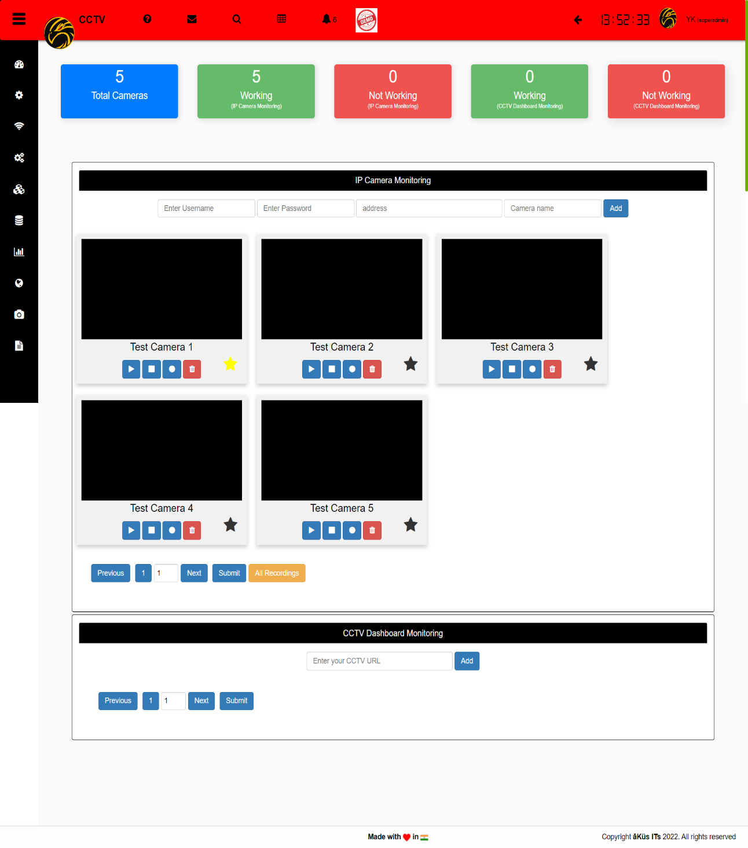

* + **Reports:** 
    - Customized Reports – Customized Reports as per your requirements.
    - Audit Report – Generate Audit report and share with your auditor to easy and fast auditing.

**Contact us**

**India Global**Delhi | Noida MENA (Dubai)

SEA (Singapore)

****[**www.akus.co.in**](http://www.akus.co.in)[**www.akus.io**](http://www.akus.io)  [**support@akus.io**](mailto:support@akus.io) ****[**support@akus.io**](mailto:support@akus.io)

****(+91) 88 5165 9023 ****(+971) 5649 33966 | (Soon)

****(+91) 1800 309 9987 [Toll Free]

**follow us**

|  |  |  |  |  |
| --- | --- | --- | --- | --- |
|  | created with MySignature.io | created with MySignature.io |  | Youtube - Free social media icons |



**™**

**© 2018- 2022 āKüs®. All rights Reserved.**



**[ SCAN ]**  
 For Privacy Policy